SDA ASSIGNMENT #1
Group Members
- Muqeet Mahmood 24P-0606
- Hammad Kashif 24P-0631
- Ali Irtaza 24P-0607

Introduction
The SeniorHub platform is designed to help final year students efficiently manage their academic, project, and career-related responsibilities. In many university environments, final year processes like forming Final Year Project (FYP) groups, finding supervisors, applying for initial jobs, and getting graduation clearance are handled through scattered, manual, and inefficient channels.
This system provides a centralized digital platform where senior students can collaborate. Users can form FYP groups, browse faculty directories, send supervision requests, submit project deliverables, and track their graduation clearance checklists in real time. Additionally, the system features a career module for job applications and alumni networking.
The system improves transparency, communication, and efficiency in managing the chaotic final year experience. It ensures that students stay on top of critical deadlines, faculty can easily manage project groups, and administration can streamline the graduation clearance process.

Functional Requirements
FR ID | Priority | Description | Actor | Status
FR-01 | High | The system shall allow users to register using university email. | All Users | Mandatory
FR-02 | High | The system shall allow users to log in securely. | All Users | Mandatory
FR-03 | High | The system shall allow students to create an academic/professional profile. | Student | Mandatory
FR-04 | Medium | The system shall allow users to reset forgotten passwords. | All Users | Mandatory
FR-05 | High | The system shall allow a student to create an FYP group and generate an invite link. | Student | Mandatory
FR-06 | High | The system shall allow students to join an FYP group using an invite code. | Student | Mandatory
FR-07 | Medium | The system shall provide a directory of faculty members and their research domains. | System | Mandatory
FR-08 | High | The system shall allow group leaders to send FYP supervision requests. | Student | Mandatory
FR-09 | High | The system shall allow groups to upload initial FYP proposal documents. | Student | Mandatory
FR-10 | High | The system shall display upcoming FYP milestones and deadlines. | System | Mandatory
FR-11 | High | The system shall allow students to submit final FYP deliverables (reports/code). | Student | Mandatory
FR-12 | High | The system shall allow faculty to review and grade submitted deliverables. | Faculty | Mandatory
FR-13 | Medium | The system shall display a job and internship board. | System | Mandatory
FR-14 | High | The system shall allow students to apply for jobs using their profile resume. | Student | Mandatory
FR-15 | Low | The system shall provide a searchable Alumni Directory. | System | Optional
FR-16 | Medium | The system shall allow students to send direct messages to Alumni. | Student | Optional
FR-17 | High | The system shall display a personalized graduation clearance checklist. | Student | Mandatory
FR-18 | High | The system shall allow the Admin to update a student's clearance status. | Admin | Mandatory
FR-19 | Medium | The system shall allow students to request a provisional transcript. | Student | Optional
FR-20 | Medium | The system shall send automated notifications for deadlines and clearance updates. | System | Mandatory

Non-Functional Requirements
NFR ID | Category | Requirement Description
NFR-01 | Availability | The system shall ensure an uptime of 99.9% for uninterrupted access.
NFR-02 | Performance | The system shall load user dashboards and process requests in under 2 seconds.
NFR-03 | Scalability | The system shall support at least 5,000 concurrent users without lag.
NFR-04 | Security | The system shall hash all passwords and encrypt data using HTTPS/TLS.
NFR-05 | Security | The system shall ensure data confidentiality and integrity.
NFR-06 | Usability | The user interface shall be responsive and functional on both mobile and desktop.
NFR-07 | Compatibility | The system shall be compatible with all major browsers (Chrome, Safari, Edge).
NFR-08 | Reliability | The system shall perform automated daily backups of all student and FYP data.
NFR-09 | Data Integrity | The system shall strictly prevent a student from joining multiple active FYP groups.
NFR-10 | Access Control | The system shall strictly manage permissions based on user roles (Admin, Faculty, Student, Alumni).

Use-Case Diagram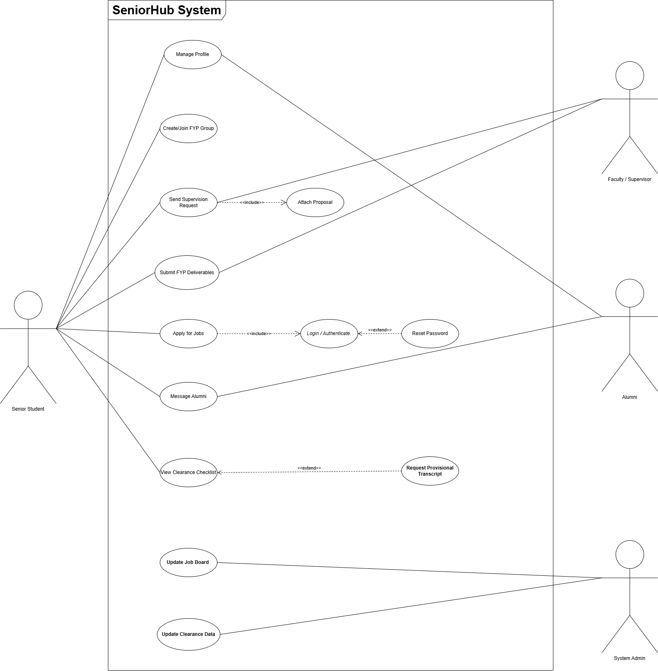

Class Diagram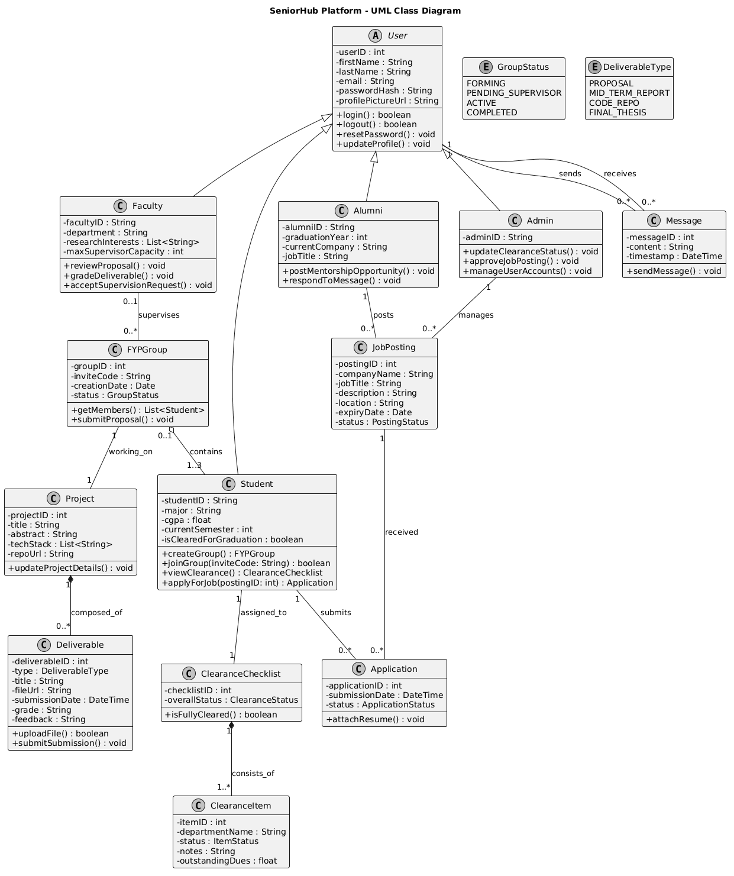

UML Specifications
Class | UML Specifications
Student | 1. A Student can create or join one FYP Group.  2. Students can view their clearance checklist and apply to Job Postings.  3. Student accounts are managed by the System Admin.  4. Students can send messages to Alumni.
Faculty | 1. Faculty can receive multiple Supervision Requests from different FYP Groups.  2. Faculty can accept or reject requests based on their availability.  3. Faculty reviews and updates the status of Deliverables submitted by their assigned groups.
FYP_Group | 1. An FYP Group consists of 1 to 3 Students.  2. The group generates one unique invite code.  3. A group is supervised by exactly one Faculty member once a request is approved.  4. The group submits multiple Deliverables throughout the year.
Supervision_Request | 1. Generated by the Student (Group Leader) and sent to the Faculty.  2. Contains an attached proposal document and a status (Pending, Accepted, Rejected).
Deliverable | 1. A deliverable is submitted by an FYP_Group.  2. It contains file attachments (code/reports) and submission timestamps.  3. Must be linked to a specific project milestone.
Clearance_Record | 1. Managed and updated by the System Admin.  2. Contains multiple departmental statuses (e.g., Finance, Library, Labs).  3. Can be viewed in real-time by the associated Student.
Job_Posting | 1. Managed by the Admin or posted by Alumni.  2. Contains job descriptions, requirements, and application deadlines.  3. Receives applications (resumes/profiles) from Students.
Alumni | 1. Alumni have profiles detailing their current company and job title.  2. They can receive and respond to direct mentorship messages from Students.

